**23EE281 BASIC ELECTRICAL AND ELECTRONICS ENGINEERING L T P C**

(Common to Aero, Aerospace, Mech, Auto, CSE, IT, AI &DS, Cyber Security) **2 0 2 3**

**COURSE OBJECTIVES:** The learning objective of this course is to

* To introduce the basics of electric circuits and analysis
* To impart knowledge in the basics of working principles and application of electrical machines
* To introduce analog devices and their characteristics
* To educate on the fundamental concepts of digital electronics, functional elements and working of measuring instruments
* To demonstrate the load test on DC machines, working of PN Junction diodes, Zener diodes and rectifiers.

**UNIT-I ELECTRICAL CIRCUITS 6**

DC Circuits: Circuit Components: Conductor, Resistor, Inductor, Capacitor– Ohm‘s Law-Kirchhoff‘s Laws -Nodal Analysis, Mesh analysis with independent sources only (Steadystate)- Introduction to AC Circuits –Steady state analysis of RL, RC, and RLC circuits (Simple problems only).

**UNIT-II ELECTRICAL MACHINE 6**

Construction and Working principle of DC Generators, EMF equation, Types and Applications. Working Principle of DC motors,Torque Equation,Types and Applications. - Construction, Working principle and Applications of Single- Phase Transformer.

**UNIT-III ANALOG ELECTRONICS 6**

PN Junction Diodes, Zener Diode–Characteristics & Applications–Bipolar Junction Transistor, JFET, SCR, MOSFET, – Types, I-V Characteristics and Applications – Rectifier.

**UNIT-IV DIGITAL ELECTRONICS 6**

Review of number systems, Combination allogic (adder and subtractor) – representation of logic functions-SOP and POS forms, K-map representations and minimization using K-maps (up to 3 variables).

**UNIT-V MEASUREMENTS AND INSTRUMENTATION 6**

Functional elements of an instrument, Standards and calibration, Operating Principle, types- Moving Coil and Moving Iron meters, Instrument Transformers- 85 CT and PT, DSO-Block diagram-Data acquisition.

**TOTAL:30 PERIODS**

**LAB COMPONENT**  **30 PERIODS**

1. Verification of Ohms and Kirchhoff‘s Laws.
2. Load test on DC Shunt Motor.
3. Characteristics of PN and Zener Diodes
4. Half Wave and Full Wave rectifiers
5. Implementation of Binary Adder and Subtractor
6. Study of DSO

**TOTAL: 30+30 = 60 PERIODS**

**TEXT BOOKS:**

1. KothariD P and I.J Nagrath,―Basic Electrical and Electronics Engineering‖ , Second Edition, McGraw Hill Education,2020
2. SedhaR.S.,―A textbook book of Applied Electronics‖, S.Chand & Co.,2008
3. A.K.Sawhney, Puneet Sawhney‗A Course in Electrical & Electronic Measurements & Instrumentation‘, Dhanpat Raiand Co, 2015.

# UNIT I ELECTRICAL CIRCUITS

# PART A

1. **State Ohm‟s law(April/May 2018)**

Ohm‟s law states that the current (**I**) flowing through a conductor is directly proportional to the potential difference (**V**) across the conductor provided all the physical conditions and temperature remains constant i.e. **I**  **V**

**V=IR,** Where R is the resistance of the conductor

1. **Compare the basic circuit components: Resistor, Capacitor and Inductor.**

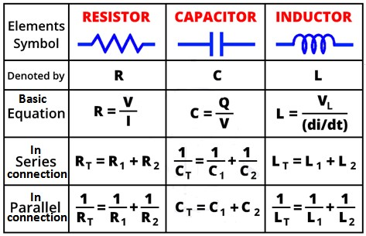

1. **Define Inductance.**

When a time varying current passes through a circuit varying flux is produced. Because of this change in flux , a voltage is induced in the circuit proportional to the time rate of change of flux or current

i.e., emf induced 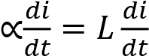

Where L,the constant of proportionality has come to be called self inductance of the circuit.Theself inductance is the property of a coil by which it opposes any change of current. It is well known that the unit of inductance is Hendry.

**4. Define Capacitance.**

A capacitor is a circuit element which, like the inductor, stores energy during periods of time and returns the energy during others. In the capacitor, storage takes place in an electric field unlike the inductance where storage is in a magnetic field. A capacitor is formed by two parallel plates separate by an insulating medium. Theemf across capacitor is proportional to the change in it i.e., e  q or e = Where C the constant is called capacitance and its unit is Farad.

**5. State the Limitation of Ohm‟s law(June 2013)**

1. Ohm‟s law cannot be applied to unilateral networks. Unilateral networks permit the current to flow only in one direction. Examples of such networks include diodes, transistors etc.
2. Ohm‟s law is ineffectual in case of non-linear objects. In these components, the current is not proportional to the voltage applied. This is because for each value of voltage and current, these components have different resistance values. Examples of non-linear components include thyristor.
3. Ohm‟s Law will not work in case of non-metallic conductors.

1. **State Independent and Dependent Sources?**

The Independent source are those, whose value of either the voltage or the current to be delivered is independent of any other parameter of the network.

The dependent sources are those, whose value of either the voltage or the current to be delivered is dependent or controlled on other parameters of the network.

1. **Define i) charge ii) electric current iii) power iv) network& v) circuit.**

**Charge:** Charge is an electrical property of the atomic particles of which matter consists, measured in coulombs(C).

**Electric current** is the time rate of change of charge, measured in amperes (A). i =dq/dt A direct current (DC) is a current that remains constant with time.

An alternating current (AC) is a current that varies sinusoidally with time

**Power** is the time rate of expending or absorbing energy, measured in watts(w).p = 

p- Power in watts(w); E- energy in joules (J);t - time in seconds (S);(or) p = v i ,v - Voltage in volts(V);i - current in amperes(A).

**Network:** The interconnection of two or more simple circuit elements forms an electric network. **Circuit:** If the network contains at least one closed path, it is an electric circuit.

1. **State Kirchoff‟s Current law and Kirchoff‟sVoltage law**

**KCL** (Kirchoff‟s Current Law) states that the algebraic sum of currents entering a node is zero (or)The sum of the currents entering a node is equal to the sum of the currents leaving the node.

**KVL** (Kirchoff‟s Voltage Law) states that the algebraic sum of all voltages around a closed path is zero. (or) Sum of voltage drop = Sum of voltage rise.

1. **What do you meant by series and parallel circuit?**

When circuit elements like resistors are connected in series, such that the same current passes through all of them, then they are said to be in series.When circuit elements are connected across one another such that the same voltage is applied to each, then the are said to be in parallel.

1. **Define: Node**

A point or junction where two or more circuit elements (resistor, capacitor, inductor, etc.) meet is called Node. In other words, a point of connection between two or more branches is known as a Node.

**11. Distinguish between a Loop & Mesh of a circuit (Dec 2010,June 2013,June 2016)**

* A loop is a closed path in a circuit where two nodes are not traversed twice except the initial point, which is also the final one. But in a loop other paths can be included inside.
* A mesh is a closed path in a circuit with no other paths inside it. In other words, a loop with no other loops inside it.

1. **Write down the expression of equivalent resistance for „n‟ - number of resistors in parallel and in series connection.**

For „n‟ resistors connected in parallel, the equivalent resistance is given by,

1 1 1 1 1

   ......... 

Re*q R*1 *R*2 *R*3 *Rn*

For „n‟ resistors connected in series, the equivalent resistance is given by,

Req=R1+R2+R3+………..+Rn

1. **Write the Algorithm for Mesh Analysis.(Dec 2012)**

Steps for solving any electrical network or circuit using Mesh analysis.

* + Step 1 − Identify the meshes and label the mesh currents in either clockwise or anti-clockwise direction.
  + Step 2 − Observe the amount of current that flows through each element in terms of mesh currents.
  + Step 3 − Write mesh equations to all meshes. Mesh equation is obtained by applying KVL first and then Ohm‟s law.
  + Step 4 − Solve the mesh equations obtained in Step 3 in order to get the mesh currents.

Then the current flowing through any element and the voltage across any element that is present in the given network can be found by using mesh currents.

1. **Write the Algorithm for Nodal Analysis.** 
   * Step 1 − Identify the principal nodes and choose one of them as reference node. We will treat that reference node as the Ground.
   * Step 2 − Label the node voltages with respect to Ground from all the principal nodes except the reference node.
   * Step 3 − Write nodal equations at all the principal nodes except the reference node. Nodal equation is obtained by applying KCL first and then Ohm‟s law.
   * Step 4 − Solve the nodal equations obtained in Step 3 in order to get the node voltages.

1. **Apply KVL and find the current in the circuit from 40V**

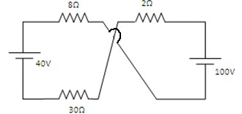

By applying KVL, 40-8I+100-2I-30I=0, Ans : I = 3.5 A

1. **Calculate the equivalent resistance between the terminals “a” and “b” in Fig(NOV 2014)**

Resistance between terminals „a‟ and „b‟ = = 5Ω

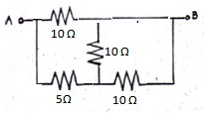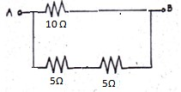

1. **Find the equivalent resistance of the circuit shown in fig.(NOV 2015)**

Equivalent resistance = 1+

Ω= 2.82

Ω

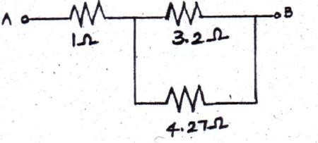

1. **State division of current rule for a two branch parallel network.(June 2013,Nov 2013)**

R1 and R2 are connected in parallel, Let I be the total current, I1 be the current through R1, I2 be the current through R2 Then I1 = I * R2/(R1+R2); I2 = I * R1/(R1+R2)

1. **State division of voltage rule for a circuit with three resistors in series.(June 2103)**

R1,R2and R3 are connected in series,Let V be the total voltage, V1 be the voltage across R1, V2 be the voltage across R2, V3 be the voltage across R,then, V1=V*R1/(R1+R2+R3),V2=V*R2/(R1+R2+R3) and V3=V*R3/(R1+R2+R3)

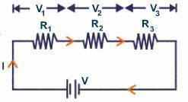

1. **Two resistors of 4 Ω and 6 Ω are connected in parallel. If the total current is 30A. Find the current through each resistor shown in below fig. (NOV 2015)**

Current through 4Ω, I

4

=

I

T

*

=

30

=

18 A

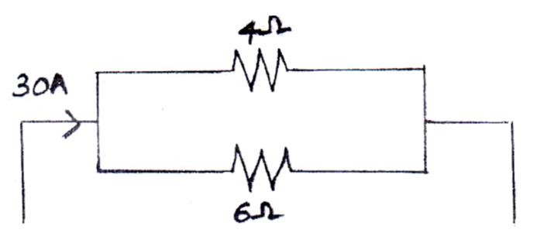

Current through 6Ω, I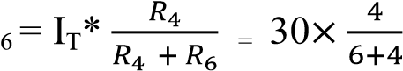 = 12 A

1. **An Inductive Circuit has an inductance of 0.4 Henry and takes a current of 0.5 Amp when connected to 200 V, 50 Hz supply. Determine the resistance of circuit. (April/May 2019)** XL = 2πf L = 2π × 50 × 0.4 = 125.66

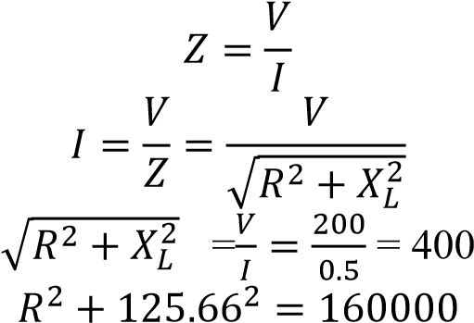

Therefore R = 379.74 Ω

1. **Define R.M.S. value of an alternating Current**

Root mean square or R.M.S. value of Alternating current is defined as that value of steady current, which would generate the same amount of heat in a given resistance is given time, as is done by A.C.

current , when maintained across the same resistance for the same time.

1. **State real power, reactive power and apparent power**

* The power dissipated by a load is referred to as real power. True power is symbolized by the letter P and is measured in the unit of Watts (W).
* Power merely absorbed and returned in load due to its reactive properties is referred to as reactive power. Reactive power is symbolized by the letter Q and is measured in the unit of Volt-AmpsReactive (VAR).
* Total power in an AC circuit, both dissipated and absorbed/returned is referred to as apparent power. Apparent power is symbolized by the letter S and is measured in the unit of Volt-Amps (VA).

1. **Define Power Factor** In an AC circuit, the quantity cos(Φ) is called the power factor. The power factor of an AC circuit is defined as the ratio of the real power (W) consumed by a circuit to the apparent power (VA) consumed by the same circuit. Therefore Power Factor = Real Power/Apparent Power, or p.f. = W/VA.

1. **State the Properties of Series RLC Circuit** 
   * The net reactance is zero at resonance and the Power Factor during that condition is unity
   * At resonance the circuit has got maximum impedance and maximum current
   * The maximum current of the circuit is given by V/R amperes • Frequency of Resonance is given by fr=1/2LC

# PART B

**1.** Determine the Current Delivered by the Source in the circuit shown in the figure below.(May 2011)

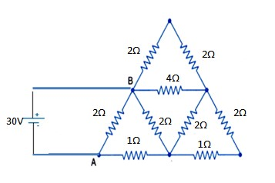

**2.**Determine the (i) Total Power Delivered by 30V Voltage source (ii) Current flowing through 15Ω Resistor (iii) Voltage across 9Ω Resistor in the figure below.(Dec 2011)

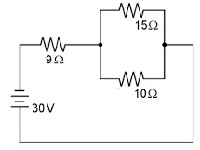

1. Determine Equivalent resistor across the terminal A and B in the following Figures (May 2015)

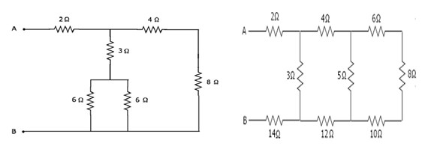

1. Apply Kirchhoff‟s Laws in the following circuit and determine the current flowing through 10Ω Resistor (Dec 2015)

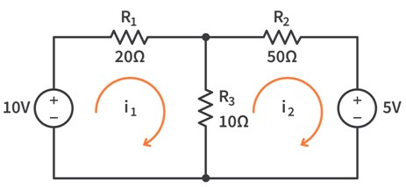

**5.**In the circuit shown in figure (i), find the current in the load resistance RL= 200 Ω (May 2019)

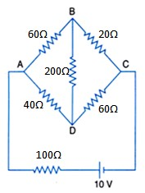

**6.** Using mesh analysis, determine the current through 1Ω resistor in the given circuit(May 2014)

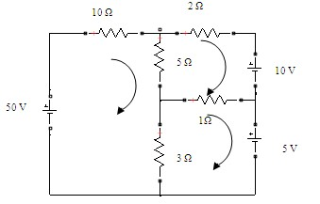

1. Determine the power dissipation in the 4 Ω resistor of the given circuit shown in below figure

(May 2014)

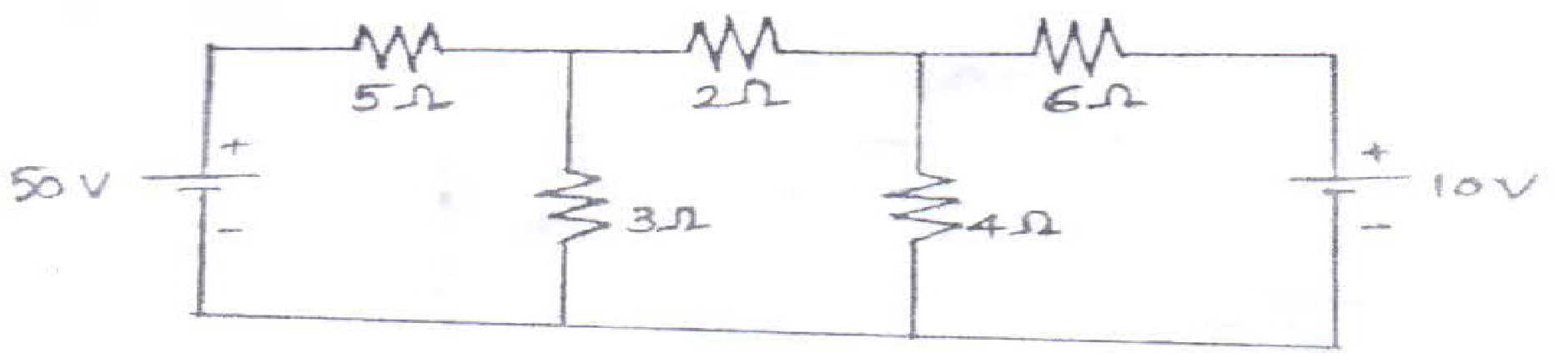

1. Determine the current I2 in the circuit shown in figure below (May 2015).

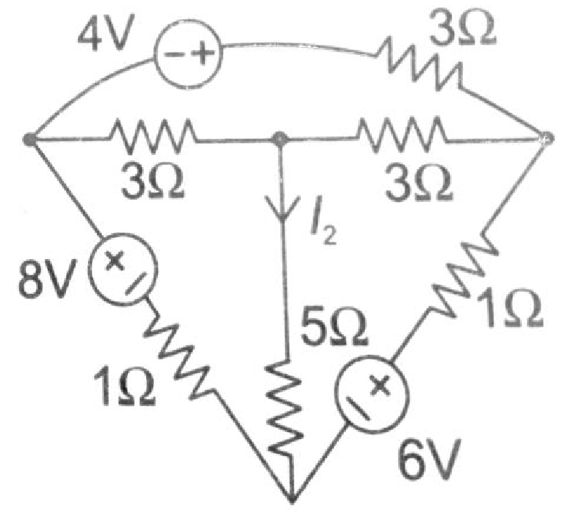

**1.** Using nodal analysis, find the node voltages and the currents through all the resistors for the circuit shown in fig (May 2013)

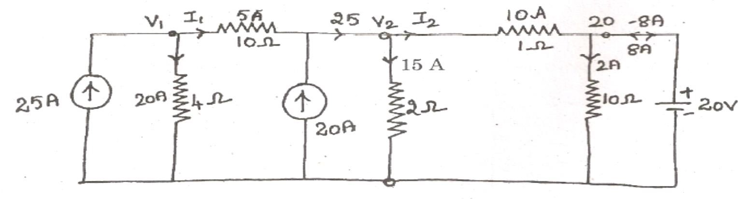

**10.**.Find the voltage across 5Ω resistor for the circuit shown in figure a) using source transformation technique and verify the results using mesh analysis.

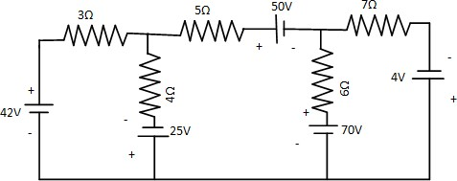

**11**. Determine the current in 12 Ω resistor for the given circuit by mesh method. (April/May 2018)

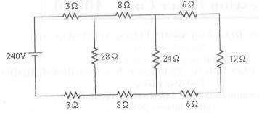

**12.**Determine the node voltage for the given circuit by nodal method. (April/May 2018)

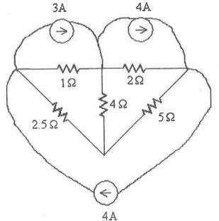

**13.** A coil of resistance 5Ω and inductance 100mH is connected in series with a 200µF capacitor across a 200V, 50Hz supply .Calculate (i) the inductive reactance (ii) Capacitance reactance (iii) impedance of the whole circuit in complex form (iv) the current (v) the power factor (vi) total power (vii) the voltage across the coil and the capacitor. Draw the illustrative phasor diagram, depicting the voltage and current. (May 2017).

# UNIT II ELECTRICAL MACHINES

**PART-A**

**1. What is the principle of operation of DC generator?(Apr 2015)**

A DC generator is an electromechanical energy conversion device that converts mechanical power into DC electrical power through the process of electromagnetic induction i.e. when the magnetic flux linking a conductor changes, an EMF is induced in the conductor. The inducedemf in a conductor is proportional to the rate of change of flux linkage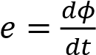

1. **List the parts of DC machine**

The parts of a DC machine are i)Yoke, ii)Poles, iii)Pole shoes, iv)Inter poles, v)Armature Core, vi) Commutator, vii)Brushes, viii)Armature winding, ix)Field winding

1. **Classify the dc machines based on their excitation.**

Based on their excitation, the dc machines can be classified into self-excited and separately excited. The self-excited dc machines can be further classified into series, shunt, compound based upon the connection between the armature and field windings.

1. **State the applications of DC generators.**
2. DC Series Generator: -i)Used in DC locomotives, ii)Series arc lighting, iii)Series Boosters
3. DC Shunt Generator: -i)Battery Charging, ii)Lighting, iii)Power Supply Purposes C) DC Compound Generator:-i)Arc Welding, ii)Lighting , iii)Power Services

1. **Draw the OCC curve of dc shunt generator.**

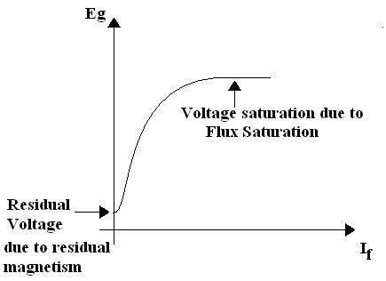

1. **List the factors affecting the emf generated in dc machine?( April/May 2018)**

The factors on which the EMF generated in a DC Machine or motor dependsare.Numbers of turns in the coil, surface area of the coil and the magnitude of magnetic field.

1. **Calculate the e.m.f generated by a 4-pole,wave –wound armature having 45 slots with 18 conductors per slot when driven at 1200 r.p.m and the flux per pole is 0.016 Wb.(Dec 2015)** P = 4,45 slots,18 conductors per slot,ϕ=0.016 Wb,N= 200 r.p.m ,wave i.e A=2 Z= 45 Х 18 =810

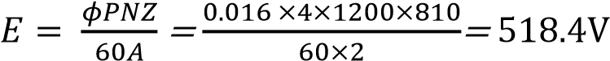

1. **What is the purpose of yoke in a d.c. machine? (Nov/Dec 2010)**

Yoke or the outer frame of DC generator serves two purposes,

* + It holds the magnetic pole cores of the generator and acts as cover of the generator.
  + It carries the magnetic field flux.In small generator; yoke are made of cast iron. Cast iron is cheaper in cost but heavier than steel. But for large construction of DC generator, where weight of the machine is concerned, lighter cast steel or rolled steel is preferable for constructing yoke of DC generator.

1. **What is the principle of operation of DC Motor?**

A DC motor is an electrical machine that converts electrical energy into mechanical energy. The working of DC motor is based on the principle that when a current carrying conductor is placed in a magnetic field, it experiences a mechanical force. The direction of the mechanical force is given by Fleming‟s Left-hand Rule and its magnitude is given by F = BIL Newton.

1. **What is back emf or counter emf?(Nov 2014)**

Since the armature of a DC motor rotates in a magnetic field, an emf is induced in the conductors of the armature due to electromagnetic induction (as in a generator). This induced emf acts in the opposite direction to the applied voltage (according to Lenz‟s law) and hence is known as back emf or counter emf.

1. **State the applications of shunt,series and compound motors.( May 2015)** 
   * DC series motor is used in a vacuum cleaner, traction systems, sewing machines, cranes, air compressors etc.
   * DC shunt motors is used in Lathe Machines, Centrifugal Pumps, Fans, Blowers, Conveyors, Lifts, Weaving Machine, Spinning machines, etc.
   * DC compound motor is used in Presses, Shears, Conveyors, Elevators, Rolling Mills, Heavy Planners, etc.

1. **Name the different types of DC motors.**

1) Shunt motor, 2)Series motor, 3)Compound motor,

3.1) Long shunt compound motor,3.1.a)Cumulative long shunt, 3.1.b)Differential long shunt, 3.2)Short shunt compound motor, 3.2.a)Cumulative short shunt3.2.b)Differential short shunt

1. **Write the torque equation for a dc motor.(May 2014)**

The torque equation of a dc motor is given by, *T*= 0.159 Ф *Z Ia*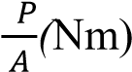, where P - No of poles;

Φ -Flux per pole; N- Speed; Z - No. of armature conductors; A- No. of parallel paths; Ia - Armature current.

1. **State the principle of working of a transformer.**

A transformer works on the principle of mutual induction. Mutual induction is the phenomenon by which when the amount of magnetic flux linked with a coil changes, an E.M.F. is induced in the neighboring coil.

1. **Define Transformation Ratio and classify the Transformer based on Transformation ratio.**  Transformation ratio is defined as the ratio of number of turns in the secondary winding to number of turns in primary winding. K= N2/N1 = E2/E1

Types : Step up transformer ( N1< N2) and Step down transformer ( N1> N2)

1. **List the various losses in a Transformer and state the Condition for Maximum efficiency.**

Types of Losses are iron loss, Copper loss, hysteresis loss, stray loss and dielectric loss.

The Condition for maximum efficiency: IRON LOSS = COPPER LOSS

1. **Define All-Day efficiency of a Transformer. (Nov 2014)(April/May 2019)**

The all-day efficiency is the ratio of output in kWh to the input in kWh of a transformer over a

24-hour period is known as all day efficiency i.e., ηall day= output in kWh /input in kWh for 24 hrs.

1. **Write the e.m.f equation of a transformer and explain the terms involved.**

E1= 4.44 Фm f N1 Volts and E2= 4.44 Фm f N2Volts ,Where **f** is the frequency of AC input, **Фm** is the maximum value of flux in the core, **N1, N2** are the number of primary and secondary turns in the transformer.

1. **Name the methods of starting a synchronous motors**

The following are the different methods to start a synchronous motor.

* + By using Pony Motors
  + By using Damper Winding
  + As a slip ring Induction motor
  + By using Small dc machine coupled to it

1. **Write the applications of synchronous motor.(Nov/Dec 2014)**

(i) Power factor improvement in sub-stations and in Industries. (ii) Constant speed drives such as motor -generator set, pumps and compressors.

1. **State the principle of 3 phase Induction Motor**

While starting, rotor conductors are stationary and they cut the revolving magnetic field and so an emf is induced in them by electromagnetic induction. This induced emf produces a current if the circuit is closed. This current opposes the cause by Lenz‟s law and hence the rotor starts revolving in the same direction as that of the magnetic field.

1. **Why an induction motor is called a 'rotating transformer'?**

The rotor receives electric power in exactly the same way as the secondary of a two-winding transformer receiving its power from the primary. That is why an induction motor can be called as a rotating transformer i.e. one in which primary winding is stationary but the secondary is tree to rotate.

1. **What is an induction generator?**

An induction generator does not differ in its construction from an induction motor. Whether the induction, machine acts as generator or motor depends solely upon its slip. Below synchronous speed it can operate only as motor, above synchronous speed it operates as generator and is now called as induction generator.

1. **What is the need of starter for induction motor?(Nov/Dec 2012)**

The three phase induction motors are self-starting due to rotating magnetic field. But the motors show tendency to draw very high current at the time of starting. Such a current can be 6 to 8 times of full load or rated current and it can damage the motor winding. Hence there should be a device which can limit such high starting current. Such a device which limits high starting current is called a starter.

1. **Name the different types of starters used for induction motor.** 
   * Stator rheostat starter
   * Autotransformer starter
   * Star-delta starter or switch
   * Direct on line starter

1. **A 220 V d.c motor has an armature resistance of 0.5 Ω. The full load armature current is 20A.Find the induced e.m.f.**

V= 220 V, Ra= 0.5 Ω and Ia = 20 A

V = Eb + Ia Ra

Eb = V - Ia Ra = 220- 20 Х 0.5 = 210 V

1. **State Three phase Alternator**

A generator running at synchronous speed and generating three-phase voltage is called a three-phase synchronous generator or alternator. Similar to the dc generator an ac generator or alternator works on the same principle i.e., Faraday's Law of Electromagnetic Induction. When a rotating armature placed in a stationary magnetic field, the armature conductors are cut by the magnetic flux. Thus, there is a change in flux linkage by the armature conductors due to its motion; hence emf is induced in the armature conductors.

# PART-B

1. Explain the principle of operation of a transformer. Derive its EMF equation.(May 2011)
2. Explain the constructional details and working of core type and shell type transformers with neat sketches (Dec 2015)
3. Discuss the construction and working principle of a D.C Generator with neat diagram.
4. Discuss about DC Separately and Self excited Generators.(April/May 2012)
5. Derive the EMF equation of a D.C Generator. (April/May 2013)
6. Explain the operating principle and construction of a D.C Motor. What is meant by back emf? What is its significance? (Dec 2010)
7. Discuss about Different types of DC Motors (April/May 2013)
8. Describe with neat sketches, the constructional details of salient pole type alternator.
9. Derive the emf equation of alternator.
10. Brief about the working of Synchronous motor.
11. Explain the construction and working of three phase induction motor.
12. Find the all day efficiency of 500 KVA distribution transformer whose copper losses and iron losses at full load are 4.5 KW and 3.5 KW respectively. During a day of 24 hours it is loaded as under:(April/May 2018)

|  |  |  |
| --- | --- | --- |
| **Number of hours** | **Loading in KW** | **Power factor** |
| 6 | 400 | 0.8 |
| 10 | 300 | 075 |
| 4 | 100 | 0.8 |
| 4 | 0 | - |

1. Explain the principle of operation of DC motor and derive its torque equation. (April/May 2019)
2. With a neat diagram explain the construction and working principle of Transformer. (May 2019)

# UNIT III ANALOG ELECTRONICS PART A

1. **Define Semiconductors.**

Semiconductors are materials having conducting properties lies between conductors and insulators. These materials are separated by a small energy gap (=1ev).Germanium and Silicon are commonly used semiconductors.

1. **Define: valence band, conduction band.**

The range of energies possessed by valence electrons is called valence band. The range of energies possessed by conduction electrons is called conduction band. The free electrons which are left in the valence band are occupying the conduction band.

1. **Define: forbidden energy gap**

The energy gap between the valence band and conduction band is defined as forbidden energy gap. For insulators. It is around 6ev, for semiconductors, its value is comparatively low. Germanium has energy gap 0.7 eV and silicon has 1.1 eV. For conductors, since conduction and valence bands are overlapping the energy gap is zero.

1. **What is intrinsic semiconductor?**

Intrinsic semiconductors are pure form of semiconductors. The conductivity of a semiconductor lies between an insulator and a conductor. As temperature increases, the conductivity of the semiconductor also increases. Semiconductors have negative temperature co-efficient of resistance.

1. **Define extrinsic semiconductor.**

The electrical conductivity of pure semiconductor can be increased by adding some impurity into it. The resulting semiconductor can be increased by adding some impurity into it. The resulting semiconductor is called extrinsic semiconductor.

1. **Why semiconductors act as an insulator at ordinary temperature?**

At absolute zero temperature there are no electrons in the Conduction band of the semiconductors and the valence band is completely filled. Therefore the semiconductors act as insulators at 0 K. As temperature increases, valence electrons gain thermal energy larger than the forbidden energy gap and move towards conduction band.

1. **Why silicon is preferred over Germanium in the manufacture of semiconductor devices?** At room temperature, a silicon crystal has almost no free electron compared with a germanium crystal. Therefore the formation of electron hole pair in silicon material at room temperature is negligibly small. i) Silicon has low leakage current, ii) silicon has higher temperature stability iii) The peak inverse voltage for silicon is higher.

1. **What is meant by N-type and P-type semiconductor?**

When a small amount of impurity (eg. Antimony, Arsenic) is added to a pure semiconductor crystal the resulting extrinsic semiconductor is N-type semiconductor. If trivalent impurity(eg.Indium, Gallium) is added to a pure semiconductor then the resulting extrinsic semiconductor is known as Ptype semiconductor.

1. **What is doping? (Dec/Jan 2016)**

The process of adding impurity to pure semiconductor is known as doping. As a result of it the characteristics of semiconductor is changed and hence the conductivity increases.

1. **State mass action law.(Nov/Dec 2016)**

Mass action law states that in a semiconductor the product of the number of holes and the number of electrons is constant and is independent of the amount of donor and acceptor impurity doping. np = ni2 where n= free electron concentration, p= hole concentration ; ni = intrinsic concentration

**11.What is a PN junction diode?**

A PN junction diode is a two terminal device consisting of a PN junction formed either of Germanium or Silicon crystal. A PN junction is formed by diffusing P type material to one half side and N type material to other half side.

1. **What is Depletion region in a PN junction diode?**

In a PN junction diode, the holes and the electrons combine to form electron-hole pair, leaving the uncovered acceptor and donor ions at the vicinity of the junction. The region where the charge carriers are depleted and has only immobile charges which are electrically charged is known as depletion region or space charge region.

1. **Define barrier potential.(Nov/Dec 2016)**

Potential barrier is defined as an electric potential that is established across the junction, during the initial diffusion of charge carriers at the junction, which restricts further movement of charge carriers across the junction.

1. **Explain the terms knee voltage and breakdown voltage.**

**Knee voltage**: The forward voltage at which the current through the PN junction starts increasing rapidly is known as knee voltage. It is also called as cut-in voltage or threshold voltage.

**Breakdown voltage**: It is the reverse voltage of a PN junction diode at which the junction breaks down with sudden rise in the reverse current.

**15.What is Zener diode and Mention the applications of zener diode.**

Zener diode is a specially designed PN junction diode. A reversed biased heavily doped PN junction diode which is operated in the breakdown region is known as Zener diode. It is also called as voltage regulator diode or breakdown diode.

**Applications:** It can be used as a voltage regulator, it can be used as a limiter in wave shaping circuits, it can be used for meter protection against damage from accidental over voltage, it can be used as a fixed reference voltage in a network for calibrating voltmeters**.**

**16.What is meant by biasing a transistor?**

Transistor biasing is the process of maintaining proper flow of zero signal collectors current and collector-emitter voltage during the passage of signal. Biasing keeps emitter-base junction forward biased and collector-base junction reverse biased during the passage of signal.

**17.Define the different operating regions of transistor.**

**Active region**: It is defined in which transistor collector junction is biased in reverse direction and emitter junction in forward direction.

**Cutoff region:** The region in which the collector and emitter junctions are both reverse-biased **Saturation region:** This region in which both the collector and emitter junctions are forward biased.

**18.How a transistor is used as a switch?**

A transistor should be operated in saturation and cutoff regions to use it as a switch,while operating in saturation region, transistor carry heavy current hence considered as ON state. In cutoff it doesn‟t carry current and it is equivalent to open switch.

**19.What are the three types of configurations?**

Common base configuration, Common emitter configuration, Common collector configuration

**20. Among CB, CE, CC which is most important?**

The CE configuration is important. The reasons are i) High current gain, ii) Output to input impedance ratio is moderate therefore easy coupling is possible between various transistor stages, iii) It finds excellent usage in audio frequency applications hence used in receivers and transmitters

**21.Which configuration is known as emitter follower and why it is named so?**

CC configuration is known as emitter follower, whatever may be the signal applied at the input, may produce same signal at the output. In other words, the gain of the circuit is unity. Hence it is called as emitter follower.

**22.Why BJT is called as Current controlled devices? (April/May 2018)**

It is a current controlled device because the base current controls the current flow from the emitter to collector. The output characteristics depend on input current.

**23.Compare JFET & MOSFET. (June 2016)**

|  |  |
| --- | --- |
| **MOSFET** | **JFET** |
| Gate is insulated from channel by a thin layer of | Gate is not insulated from channel |
| Can be operated in depletion and Enhancement modes | Can‟t be operated in depletion and enhancement modes |
| There is a continuous channel only in Depletion type, but not in enhancement type | There is a continuous channel |

**24. What are the two modes of MOSFET?** 1, Depletion mode 2, Enhancement mode **25. What are the advantages of FET?**

Input impedance is very high. This allows high degree of Isolation between the input & output Circuit.Current carriers are not crossing the junctions hence noise is highly reduced.It has a negative temperature Co-efficient of resistance. This avoids the thermal runaway.

**26. Write the application of JFET.** It is used as VVR.

It is used in high impedance amplifier.

**27.What is SCR?**

A silicon controlled rectifier(SCR) is a three terminal, four layer, three junction semiconductor device that acts as true electronic switch. It is a unidirectional device .It convertsalternating current into direct current and control the power fed to the load.

1. **Define Rectifier**:

It is an electronic circuit which converts AC input to pulsating DC. i.e., output of the rectifier is not a pure DC. Normally PN diode is used as rectifying device.

1. **Define IGBT.**

IGBT stands for insulated-gate bipolar transistor. It is a bipolar transistor with an insulated gate terminal. The IGBT combines, in a single device, a control input with a MOS structure and a bipolar power transistor that acts as an output switch. IGBTs are suitable for high-voltage, high-current applications.

1. **Whatis inverterused for?**

The primary function of an inverter is to convert Direct Current (DC) power into standard, Alternating Current (AC). This is because, whereas AC is the power supplied to industry and homes by the main power grid or public utility, the batteries of alternating power systems store only DC power.

# PART B

1. Describe the working of a PN junction diode with neat diagrams. Also explain its V-I characteristics.
2. Explain the working principle of zener diode and draw the VI characteristics and brief how it can be used as a regulator.
3. Explain the working of the CE configuration BJT. Draw its input and output characteristics.
4. Explain the construction, operation and characteristics of a n-channel JFET. Explain how the various FET parameters are calculated from the above characteristics**.**
5. With relevant diagrams, explain the operation of enhancement type MOSFET.
6. With relevant diagrams, explain the operation of depletion type MOSFET.
7. Explain the working and characteristics of SCR and its applications and Draw the two transistor model of SCR.
8. Illustrate the operation and characteristics of half wave and Full wave rectifiers with neat diagrams.
9. Explain Bridge rectifier with suitable circuit diagram and derive its efficiency, ripple factor, TUF and PIV.
10. Explain the working and characteristics of IGBT and its applications.

# UNIT IV DIGITAL ELECTRONICS PART A

1. **Convert the following decimal numbers to octal (a) 79 (b) 0.925**

ANS (a) 8 | 79

8 | 8 – 7 = (107) 8

1 - 0

(b) 0.925 * 8 = 7.400

0.400 * 8 = 3.200 0.200 * 8 = 1.600

= (0.731) 8

1. **Convert the following Hexadecimal to Decimal (a) 4C5 (b) 0.9E8**

ANS: (a) = 4 * 16 2 + 12 * 16 1  + 5 * 16 0

= (1217) 10

(b) = 9 * 16 –1 + 14 * 16 –2 + 8 * 16 -3

= (1.18164)10

1. **Convert (1259) 10 into Hexadecimal**

ANS:16 | 1259

16 | 78 – 11

3 – 14

= (3EB) 1

1. **What are non – weighted Code and Weighted Code?**

**Non weighted**: The Code in which the bit position does not have any specified value.

Example: Excess-3 code, Gray code

**Weighted code:** The code in which each and every bit position has a specified value or weight Example: 8421, 5211 and 2421

1. **What are Universal Gates? Why are they called so? What are their advantages?**

Universal gates are NAND and NOR, they are called so because using these codes any logical gate or logical expression can be derived.

1. **State Demorgan‟s theorem: (May 2016) & (May 2017)**

**Demorgan‟s theorem 1**: The complement of product of any number of variables is equivalent to sum of the individual complements.

**Demorgan‟s theorem 2**: The complement of sum of any number of variables is equivalent to product of individual Complements.

1. **Describe the importance of EBCDIC code.**

The extended Binary coded Decimal interchange code is an eight-bit code.This code is commonly Used in Data transfer & computer interface applications. In this case, the decimal digits are represented by the 8421 BCD code proceeded by 1111.

1. **What is register in digital system? (May 2016).**

Registers are data storage devices that are more sophisticated than latches. A register is a group of binary cells suitable for holding binary information. A group of cascaded flip flop used to store related bits of information is known as register.

1. **Define the following: minterm and maxterm?**

**Minterm** (standard product) is a combination of n variables using AND operation for the function of n variables. Possible minterms for a function of two variables A & B:, A‟B‟, A‟B, AB‟, AB. **Maxterm** (standard sum) is a combination of n variables using OR operation for the function of n variables. Possible maxterms for a function of two variables A & B: A+B, A+B‟, A‟+B, A‟+B‟.

1. **Minimize the function using K-map: F=∑m(1,2,3,5,6,7)**

BC

A 00

10

11

01

0

0

1

1

1

3

1

2

0

4

1

5

1

7

1

6

1

0

Quad (2,3,6,7) = B

Quad (1,3,5,7) = C

F = B + C

**11.Define positive logic and negative logic system.**

**Positive logic:** In positive logic system the high level H represents logic 1. **Negative logic:** In negative logic system the low level L representslogic1.

1. **Distinguish between combinational logic and sequential logic.**

|  |  |  |
| --- | --- | --- |
| **S.No** | **Combinational logic circuit** | **Sequential logic circuit** |
| 1 | It consists of input signal, gates and output signals | It consists of a combinational circuit to which memory elements are connected to form a feedback path. |
| 2 | The outputs at any instant of time are entirely dependent upon the inputs present at that time. | The outputs dependent not only on the present input variable but they also depend upon the past value of the input variable. |
| 3 | Combinational circuits are faster in speed | Sequential circuits are slower than the combinational circuits. |
| 4 | Combinational circuits are easy to design | Sequential circuits are comparatively harder to design |
| 5 | Example: Parallel adder, Code converter, Decoder | Example: Serial Adder, Counter, shift register |

1. **Write the design procedure of combinational circuit.(MAY/JUNE 2016)**

The design procedure for combinational logic circuits starts with the problem specification and comprises the following steps:

* 1. Determine required number of inputs and outputs from the specifications.
  2. Derive the truth table for each of the outputs based on their relationships to the input.
  3. Simplify the boolean expression for each output. Use Karnaugh Maps or Boolean algebra.
  4. Draw a logic diagram that represents the simplified Boolean expression. Verify the design by analysing or simulating the circuit.

1. **Draw the 4 bit Gray to Binary code converter.**

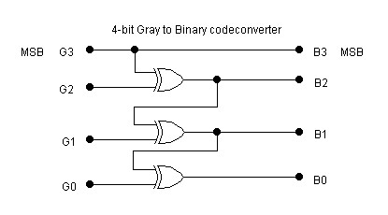

1. **Draw the 4 bit Binary to Gray code converter.**

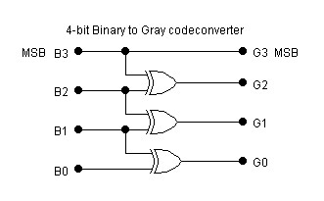

**16.Describe the importance of don′t care conditions.**

Functions that have unspecified outputs for some input combinations are called incompletely specified functions. We simply don′t care what value is assumed by the function for the unspecified minterms. These unspecified minterms are called don′t care conditions. These don′t care conditions can be used on amap to provide further simplification of the Boolean expression.

**17.Give the canonical SUM form of : F=(x1+x2+x3) (x1′+x2+x3′)(x1′+x2′+x3)(x1′+x2′+x3′)**

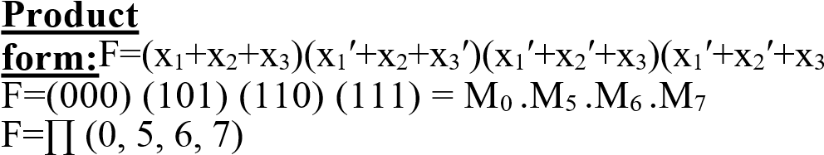′)

Collecting the missing terms in the Product form of F derives the SUM form of F.



=x1′x2′x3+x1′x2x3′+x1x2′x3′+x1′x2x3

1. **Define Karnaugh map.**

Karnaugh map is a map method that provides a simple, straightforward procedure for minimizing Boolean functions in canonical form. This method may be regarded as a pictorial form of a truth table. AK-map is a diagram made up of squares, with each square representing one minterm of the function that isto be minimized.

1. **What are the two forms of Boolean expressions?**

Two forms of a function, one is a Sum of Products (SOP) form (either standard or normal), the other a Product of Sum (POS)form (either standard or normal).

1. **What is the significance of BCD code?** 
   1. Any large decimal number can be easily converted into corresponding binarynumber
   2. Apersonneedstorememberonlythebinaryequivalentsofdecimalnumberfrom0to9 (iii) ConversionfromBCDintodecimalisalsoveryeasy.

1. **Whatismeantbyself-complementingcode? (Nov./Dec.‟2017)**

Self-complementing codes provide the 9′s complement of a decimal number, just by interchanging 1′s and 0′s in its equivalent 2421 representation. Ex: the code for 8 is the complement of the code for 1. The 2421, 5211, 642-3, 84-2-1 and XS-3 are self-complementing codes. For a code to be selfcomplementing, the sum of all its weights must be equal to 9.

1. **Classifythelogicfamiliesbyitsoperations.(Apr/May„2017)**

Digital integrated circuits are classified not only by their complexity or logical operation, but also by the specific circuit technology to which they belong. The circuit technology is referred to as a digital logic family. The digital logic families are classified as:

* + TTL transistor–transistorlogic.
  + ECLemitter coupledlogic.
  + MOSmetal oxidesemiconductor.
  + CMOScomplementarymetal oxidesemiconductor.

**23.Show that the excess-3 code is self-complementing.**

**Self-complementingproperty:**1′scomplementofXS-3codeofadecimaldigitisequaltoXS-

3code of 9′s complement of the corresponding decimaldigit.

**Example:** XS-3 code of decimal digit2=0101 …(1) XS-3 code of decimal digit7= 1010…(2)

* + The self- complementing property of XS-3 code is proved from equations (1) & (2)

**24.Give the truth table for half adder and write the expression for sum and carry.** Ahalfadderisalogicalcircuitthatperformsanadditionoperationontwobinarydigits.Thehalf adder producesasumandacarryvaluewhichisbothbinarydigits.Thedrawbackofthiscircuitisthati ncaseof amultibitaddition,itcannotincludeacarry.**Expression:S=A****B,C=A.B**.

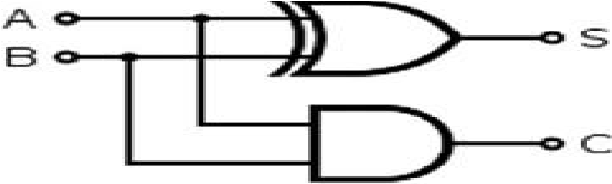

**Logic table for a half adder:**

|  |  |  |  |
| --- | --- | --- | --- |
| **A** | **B** | **C** | **S** |
| 0 | 0 | 0 | 0 |
| 0 | 1 | 0 | 1 |
| 0 | 0 | 0 | 1 |
| 0 | 1 | 1 | 0 |

**25. Implement a full adder with two half adder.**

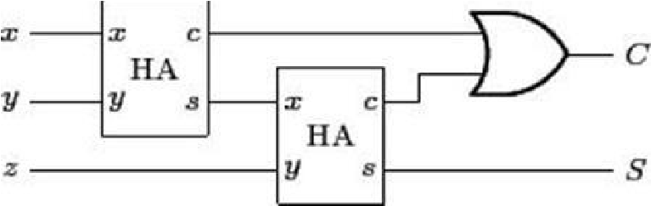

# PART B

1. Simplify the given Boolean function in POS form using K-map and draw the logic diagram using only NORgates.F(A,B,C,D)=∑m(0,1,4,7,8,10,12,15)+d(2,6,11,14)

2.Simplify the following functions usingK-maptechnique **(May/June2014)**

(i) G=ΠM(0,1,3,7,9,11) (ii)f(W,X,Y,Z)=∑m(0,7,8,9,10,12)+∑d(2,5,13)

3. i) SimplifytheBooleanfunctioninSumofProducts(SOP)andProductofsums(POS)

F(A,B,C,D) = ∑m(0,1,2,5,8,9,10) ii) Plot the following Boolean function in Karnaugh map and simplifyit. F(w,x,y,z) =∑m(0,1,2,4,5,6,8,9,12,13,14)

4.Solve the following using K-map and verify using boolean algebra: F (A, B, C, D) = ∑m (3, 4, 5,7, 9, 13, 14, 15)

5.Design and implement binary to gray code converter.

6. Design a combinational circuit to perform BCD addition.

7.Realize the circuit of a full adder in terms of two half adders from its truth table.

8. Explain the error corrections and detections methods of digital systems.

9.Design Half/Full Subtractor circuits.

10.Design a full adder with x, y, z and two outputs S and C. The circuits performs x+y+z, z

is the input carry,C is the output carry and S is the Sum.**(April/May 2019)**

# UNIT V - MEASUREMENTS AND INSTRUMENTATION PART-A

**1. What is meant by a measuring instrument?**

A measuring instrument is a device for measuring a physical quantity. In the physical sciences, quality assurance, and engineering, measurement is the activity of obtaining and comparing physical quantities of real-world objects and events. Established standard objects and events are used as units, and the process of measurement gives a number relating the item under study and the referenced unit of measurement.

1. **Mention the basic requirements of measurement.**

The necessary or essential requirements for any measuring instrument are

* 1. When the instrument is used in the circuit, its conditions should not be altered and therefore the quantity to be measured goes unaffected.
  2. It should consume low power as possible.
  3. It should possess a very high efficiency and high sensitivity.
  4. The output should be linearly proportional to the input.
  5. It should be less affected by the noise, modifiable and properly priced.

1. **Primary sensing element?**

The first unit in the measurement system which detects the measurand is known as primary sensing unit.It helps in transferring the measurand to variable –conversion unit for further processing. For example,liquid or mercury in glass thermometer acts as primary sensing unit. Displacement or voltage is the output in the primary sensing unit.

1. **Define static sensitivity. ( Dec 2016)**

It is the ratio of the magnitude of the output signal or response to the magnitude of the output signal or the quantity being measured.

Static sensitivity 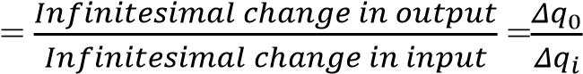

1. **Define dead time and dead zone.**

**Dead time:** It is the time required by a measurement system to begin to respond to a change in the measurand.

**Dead zone:**It is defined as the largest change of input quantity for which there is no output of the instrument.

1. **Define reproducibility.**

Reproducibility is the deviation of the results obtained when the same sample is measured continuously for multiple times with changed measuring conditions.

1. **What is meant by loading effect?(Dec 2015,May 2015, May 2017)**

Under practical conditions, it has been found that introduction of any element in a system results invariably in extraction of energy from the system thereby distorting the original signal. This distortion may take the form of attenuation, waveform distortion or phase shift. The incapability of the system to faithfully to measure, record or control the input signal in undistorted form is called Loading effect.

1. **Define limiting errors.(May 2015)**

It refers to the largest error in an experiment, causing the greatest inaccuracy in the final measurement. Alternatively, it might be referring to the uncertainty which remains after all experimental error has been eliminated.

1. **State static Characteristics of a measuring system( April/May 2014)**

The set of criteria defined for the instruments, which are used to measure the quantities which are slowly varying with time or mostly constant, i.e., do not vary with time, is called „static characteristics‟. The main static characteristics include: (i) Accuracy, (ii) Sensitivity, (iii) Reproducibility, (iv) Drift, (v) Static error, and (vi) Dead zone

1. **Name the different types of errors in measurement systems. (April/May 2018)**

The different types of errors in measurement system is given below

**i.** Gross errors: caused by human mistakes in reading/using instruments. **ii.** Measurement errors: measurement error is the difference between a measured value of a quantity

and its true value. it is of two types (1) Systematic errors (2) Random errors

Systematic errors are again classified in to (a) Instrumental errors (b) Environmental errors (c) Observational errors (d) Theoretical errors.

1. **Compare moving coil and moving iron instruments based on any two salient features. (May 2019)**

|  |  |  |
| --- | --- | --- |
| **Basis for**  **Comparison** | **Moving Iron Instrument** | **Moving Coil Instrument** |
| Definition | In moving iron instrument the soft iron is used for moving mechanism. | In moving coil instrument the conductor coil is used for measuring the current and voltage. |
| Working  Principle | Magnetism | Similar to working principle of DC Motor |
| Uses | Both for AC and DC measurement | DC Measurement |
| Accuracy | Less | More |
| Scale | Non-uniform | Uniform |
| Damping | Air Friction Damping | Eddy Current Damping |
| Controlling Torque | Gravity or spring | Spring |
| Deflection | Proportional to Current | Square of current |

1. **State the errors in PMMC instruments.**

The basic sources of error in PMMC instruments are friction, temperature and aging of various parts. To reduce the frictional errors ratio of torque to weight is made very high.The most serious errors are produced by the heat generated or by changes in the temperature. This changes the resistance of the working coil, causing large errors.

1. **What causes errors in moving iron instruments?**

Temperature coefficient of spring, self-heating of coils in voltmeters, stray magnetic field, changes of reactance of working coils, changes of magnitudes of eddy currents cause errors in moving iron instruments.

1. **Enumerate the merits of attraction and repulsion type MI instruments?**

|  |  |
| --- | --- |
| **Attraction type** | **Repulsion type** |
| a. Lower value of inductance  b.Accurate over a wider range of frequency and  Greater possibility of using shunts with ammeters. | a.Suitable for economical production.  b. Uniform scale |

1. **Define creeping in energy meter.(May 2014, Dec 2015, May 2016)**

Creeping in [energy meter](https://circuitglobe.com/energy-meter.html) is the phenomenon in which the aluminium disc rotates continuously when only the voltage is supplied to the pressure coil, and no current flows through the current coil. In other words, the creeping is the kind of error in which the energy meter consumes a very small amount of energy even when no load is attached to the meter.

1. **Mention the name of the torques present in an indicating instrument?**
2. Deflecting torque
3. Controlling torque
4. Damping torque

## 17. List out the various types of damping provided for an indicating instrument

Damping is the dissipation of energy of rotation. It is provided by any one of the following types

* Air friction damping
* Fluid friction damping
* Eddy current damping
* Electromagnetic damping

## 18. Write the expression for the power measured by two watt meters used in 3- phase balanced load, in terms of voltage, current and power factor ( June 2012)

W1 = VLILcos(30 +)

W2 = VLILcos(30 -)

## 19. Write the expression for power factor in two wattmeter method of power measurement

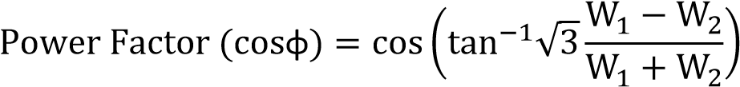

1. **Which torque is absent in Energy meter? Why?**

The controlling torque (Tc) is absent in Energymeter because the aluminium disc has to rotate continuously and there is no need to reset its position.

1. **What is Instrument transformer?**

Instrument transformers are small transformers used in conjunction with high accuracy measuring instruments such as ammeters, voltmeters, power meters, and protective relaying used for protective circuits .These transformers step down the voltage or current of a circuit to a low value that can be effectively and safely used for the operation of instruments. Instrument transformers also provide insulation between the instrument and the capacitor voltage of the power circuit.

## 22. Compare CT and PT

|  |  |
| --- | --- |
| **CT (Current Transformer)** | **PT ( Potential Transformer )** |
| **1.** It is connected in series with the power circuit. | It is connected in parallel with the power circuit. |
| **2.**CT step-down the high current to the safe level of current. | PT step-down the high voltage levels to the safe level of voltage. |
| **3.**Its secondary is connected to Ammeter | Its Secondary is connected to Voltmeter |
| **4.**It has a fewer number of turns in its primary winding. | It has a large number of turns in its primary winding. |
| **5.**It has a large number of turns in the secondary winding. | It has few numbers of turns in the secondary winding. |
| **6.**Its secondary cannot be open circuit. | Its secondary can be open circuit. |
| **7.** Its secondary work always in short circuit condition. | Its secondary work always in open circuit condition |

**23. What is DSO?**

The digital storage oscilloscope is an instrument which gives the storage of a digital waveform or the digital copy of the waveform. It allows us to store the signal or the waveform in the digital format, and in the digital memory also it allows us to do the digital signal processing techniques over that signal. The maximum frequency measured on the digital signal oscilloscope depends upon two things they are: sampling rate of the scope and the nature of the converter. The traces in DSO are bright, highly defined, and displayed within seconds.

## 24. Give the Block Diagram of Digital Storage Oscilloscope

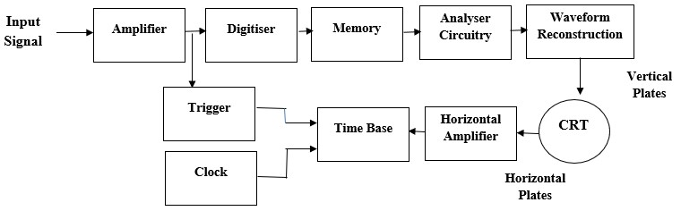

## 25. Difference between analog storage and digital storage oscilloscope

|  |  |
| --- | --- |
| [**Analog storage oscilloscope**](http://www.polytechnichub.com/difference-analog-storage-digital-storage-oscilloscope/) | **Digital storage oscilloscope** |
| The [analog](http://www.polytechnichub.com/comparison-analog-voltmeter-digital-voltmeter/) storage oscilloscope has higher bandwidth and writing speed. | The digital storage oscilloscope has lower bandwidth and writing speed than analog storage oscilloscope. |
| In analog storage oscilloscope, CRT is expansive than digital storage oscilloscope. | In digital storage oscilloscope, CRT is much cheaper. |
| There is no such digital memory is present. | Because of digital memory, digital storage oscilloscope capable of an infinite storage time. |
| It cannot operate with a constant CRT refresh time. | It can operate with a constant CRT refresh time. |
| It gives lower resolution than digital storage oscilloscope. | It gives higher resolution because of analog to digital converter used in it. |

**26. How is the focusing of an electron beam obtained in cathode ray tube(CRT)?**

Electrons are negatively charged particles. So it will move towards a positive charge or moves away from negative charge. In other words, it's motion is affected by electric field.So in CRTs, the electrons are deflected by applying electric field perpendicular to the electron beam's direction. More specifically, there are deflection coils which generate electric fields in horizontal and vertical directions which controls the beam's left-right position and up-down position respectively.

# PART – B

1. Explain the static and dynamic characteristics of an instrument.
2. Explain different types of Errors in Instruments.
3. Describe the construction and working of permanent magnet moving coil instrument. Also derive the expression for deflection.(April/May 2018)
4. With neat figure, explain the construction and operation of repulsion type moving iron instrument. Give the advantages and limitations of such instruments.
5. With neat figure, explain the construction and operation of attraction type moving iron instrument.
6. With neat figures explain the construction, working principle of a three phase wattmeter.
7. With circuit and phasor diagram, explain the working of single phase AC energy meter.
8. Explain the workingof DSOwith a neat block diagram.
9. With a neat sketch explain the construction and principle of operation of energy meter.

(May 2019)

1. Discuss about Instrument transformer-working principle, types, connections and Advantages